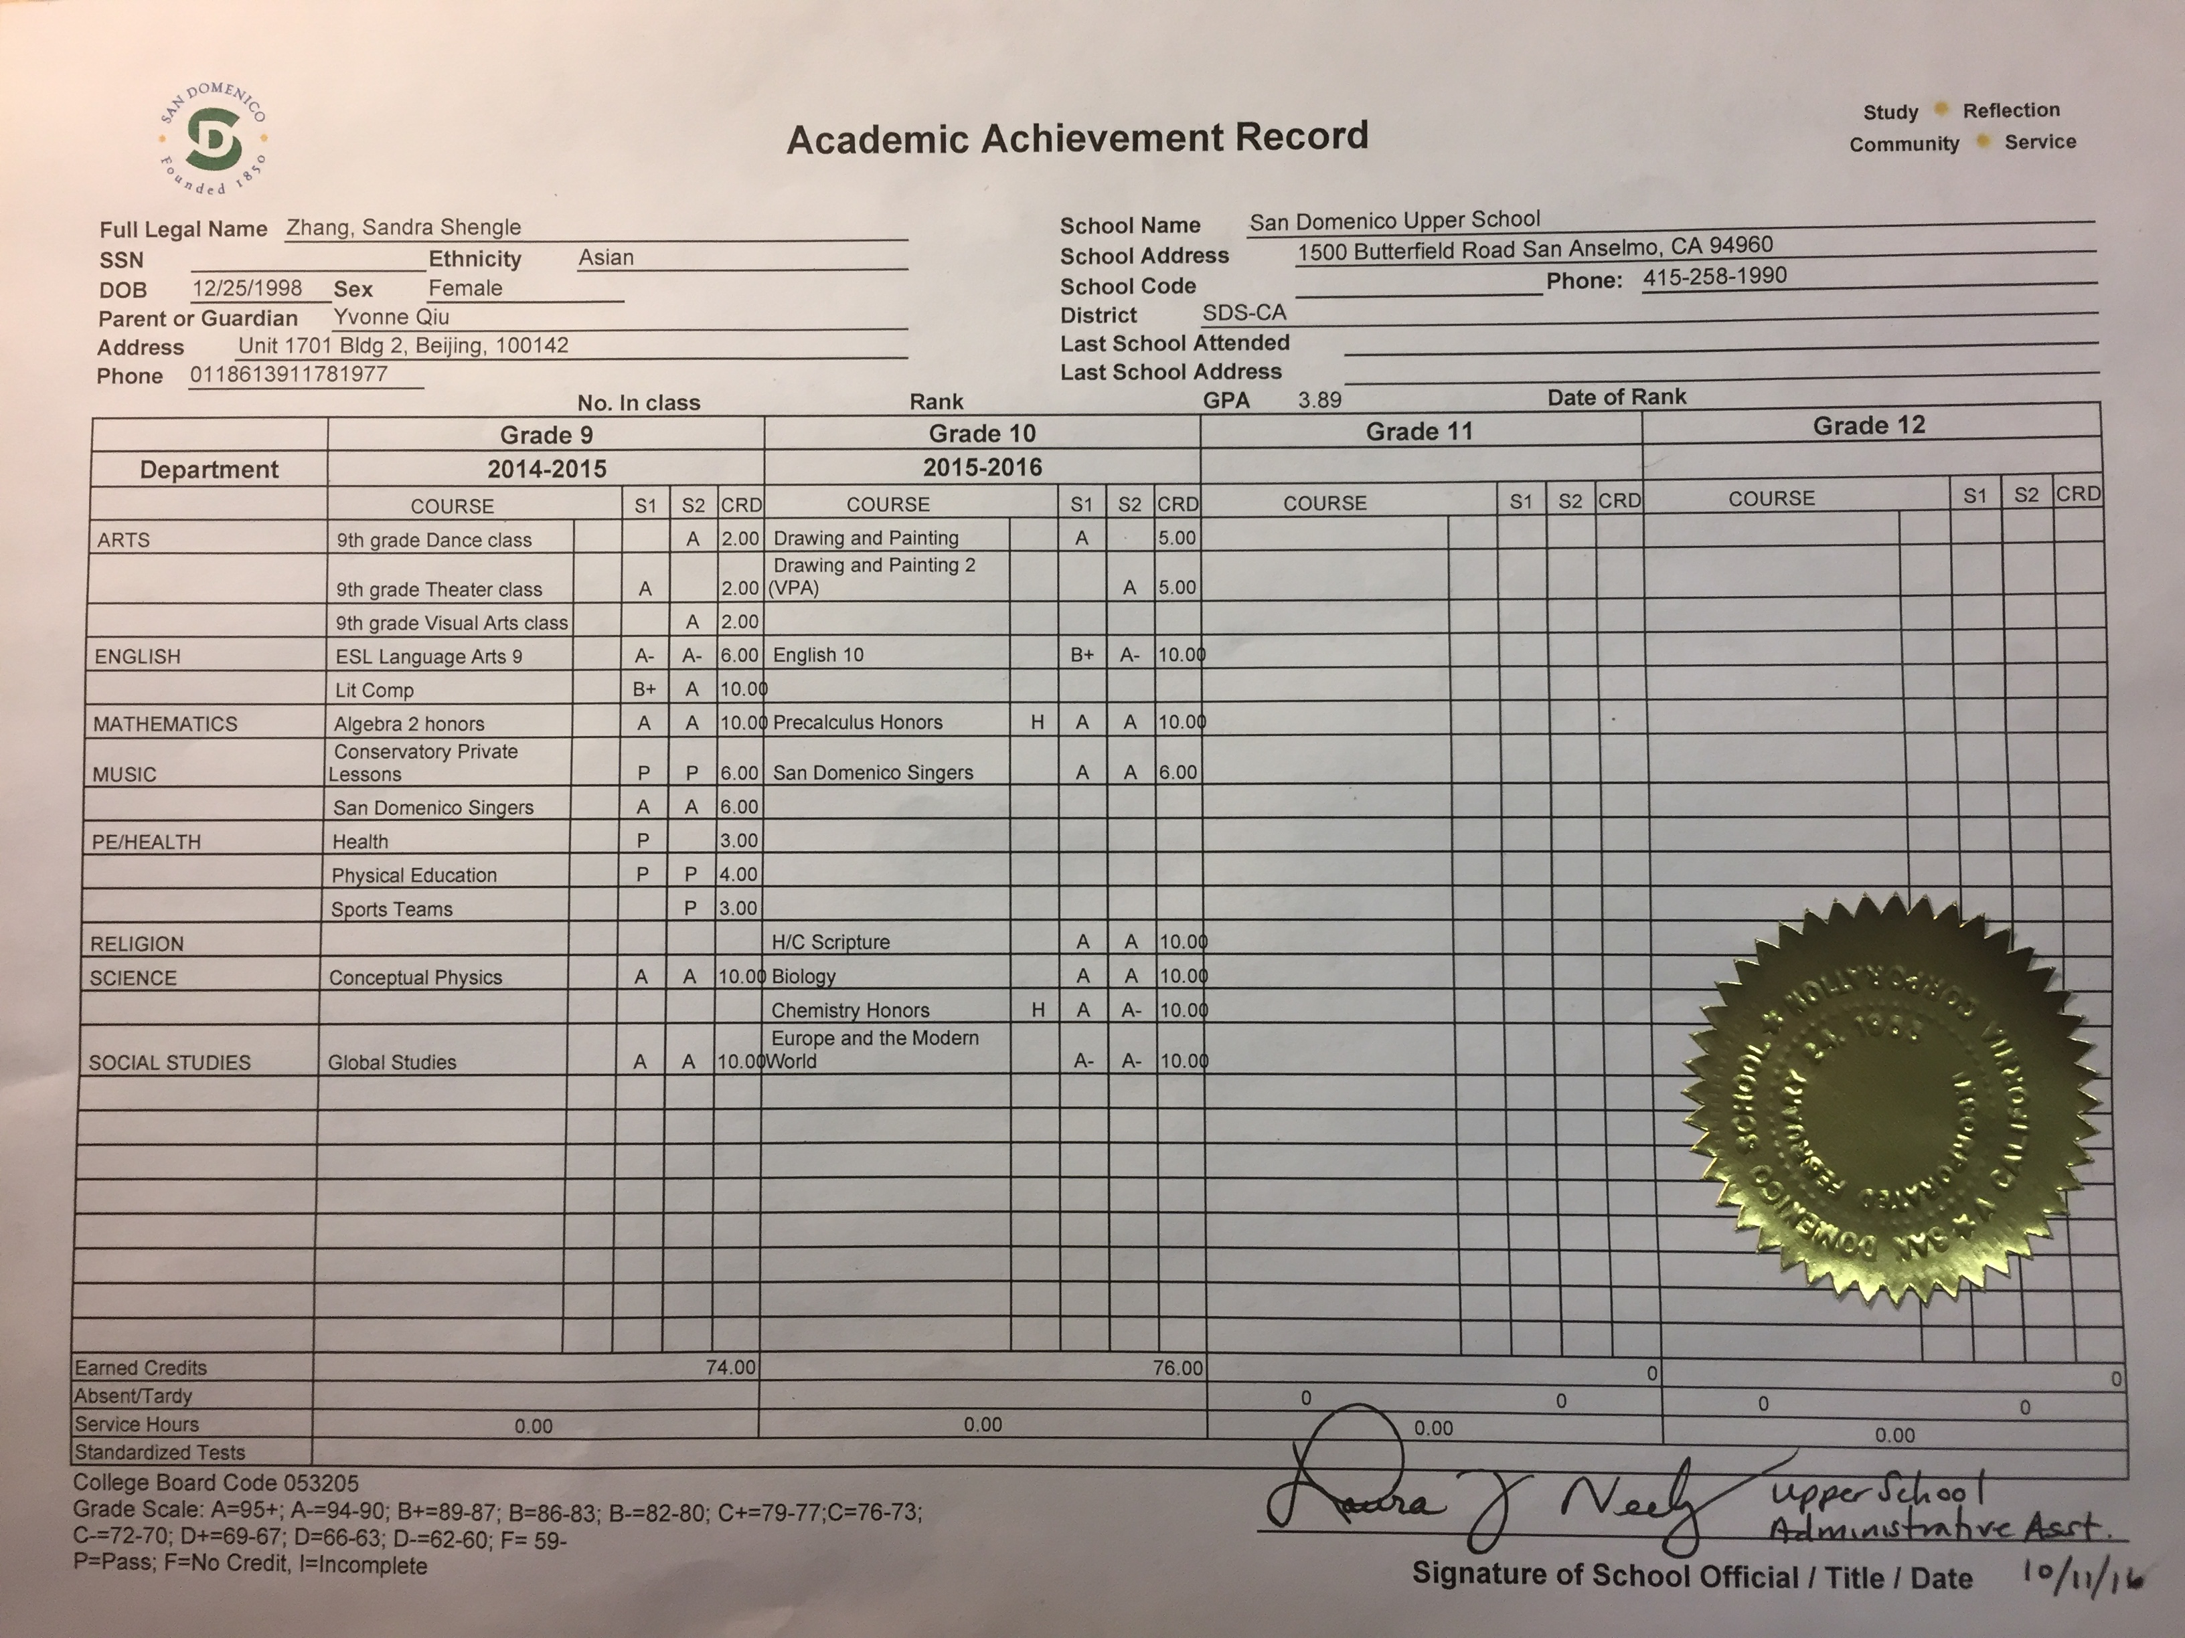
• Past two years of transcripts

- Current courses and grades

• Any other courses you've taken during your high school career
Freshmen year:
ESL, Literature Composition, Conceptual physics, Art, Algebra 2 Honors, Global Studies, PE, Health, Drums lesson
Sophomore Year:
PreCalculus Honors, English 10, Biology, Chemistry Honors, Art 2, Europe and the Modern World (History), H/C Scripture (religion).
Junior Year:
Social Justice, English 11(American Literature), US History, AP Physics C, AP Calculus BC, AP Chemistry.

- A list of extra-curricular activities that you've participated in, how many years you've participated in them and how many hours you dedicate to each per week/month/semester;
1. San Domenico Singers: this year is my third year in the choir. I have it 3 days per week and an hour for each day.
2. Children in Need: only a year. every Tuesday 3 hours.
3. Badminton Team: two years, 2 hours of practice everyday.

- The area of academic interest that you most enjoy (math, science, history, etc.)
I’m interested in math, history, and religion.
- The area of non-academic interest that you most enjoy (music, dance, sports, etc.)
I’m interested in singing, badminton, track and field.

• An academic or professional goal that you currently think you'd like to pursue ("I want to be a doctor" or "I want to teach science" or "I want to be a businessman", etc.)
I want to be an engineer. Specifically, Civil Engineer.

